W-18

**YEAR 12 PHYSICS**

**ASSIGNMENT 6 - LIGHT & ATOMIC PHYSICS**

**Name:** **Mark:** 

1. The first five energy levels (not to scale) of a hydrogen atom are shown in the figure below.

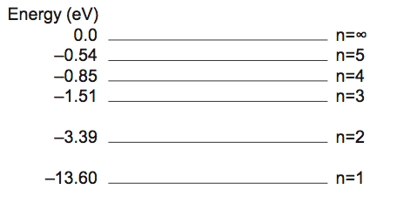

(a) Calculate the highest and lowest frequency photons that an excited electron in the n = 5 level within a hydrogen atom can emit. Show **all** workings. (4 marks)

Highest: Hz Lowest: Hz

(b) In the diagram below, indicate the possible pathways by which an electron at energy level n = 3 can return to ground state. (3 marks)

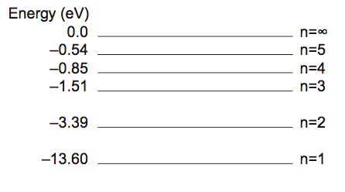

2. Electromagnetic radiation (emr) is said to have both wave and particle properties. State and describe an example of each of these properties of emr.   (4 marks)

3. The images below show hydrogen spectra.

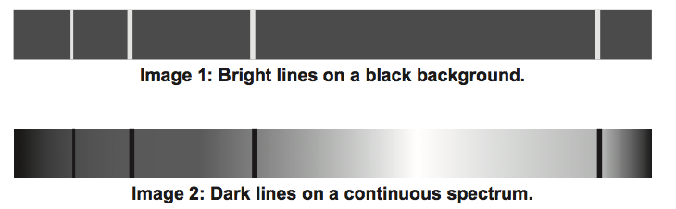

For each, name the type of spectrum and describe how it is created. (4 marks)

Image 1 spectrum type:

Created:

Image 2 spectrum type:

Created:

4. A hydrogen atom, in an excited energy level, undergoes relaxation by emitting a photon. The energy values are given by . The initial state of the electron is in energy level n = 4 and the final state after relaxation is ground state (n = 1).

(a)   Does the average radius of the electron orbital remain the same, increase or decrease in value during this transition? Circle the correct answer. (1 mark)

**remains the same increases decreases**

(b)   Use the formula to complete the energy level diagram below. The diagram is **not** drawn to scale. (2 marks)

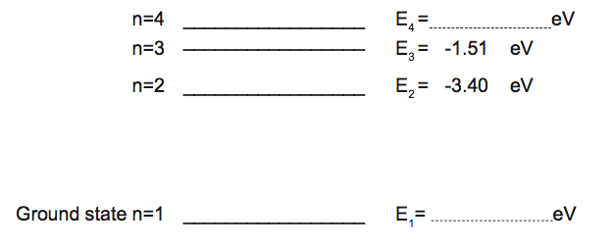

(c) On the diagram above, draw in all the possible transitions when an electron undergoes relaxation from n = 4 to the ground state. (3 marks)

(d) (i) Calculate the wavelength of the photon emitted from the E3 to E2 transition. Show **all** workings. (4 marks)

(ii) The transitions of E4 to E2 and E3 to E2 produce red and green photons. Explain which transition produces which colour. (3 marks)

5. The element helium gets its name from the Greek sun god ‘Helios’. This is because helium is the only element to have been discovered in the Sun before it was isolated on the Earth. Helium was identified from unknown lines in the solar spectrum.

With reference to the discovery of helium, explain the origin and significance of lines in the solar spectrum. (4 marks)

6. Experimental work was carried out to investigate the photoelectric effect by shining light onto a particular metal surface. Measurements were made of the number and maximum kinetic energy of the emitted electrons from this particular metal surface for different frequencies and intensities of light.

(a) Which **one** of the following (**A - D**) was **not** one of the findings? (1 mark)

A. The ability to eject electrons from this metal depended only on the frequency of light.

B. At frequencies below the 'threshold frequency' no electrons were ejected from the metal no matter how high the intensity was.

C. The 'stopping potential' for the photoelectrons was independent of the light intensity.

D. The maximum kinetic energy of the photoelectrons depended only on the intensity of the light.

The apparatus shown below was set up to investigate the photoelectric effect.

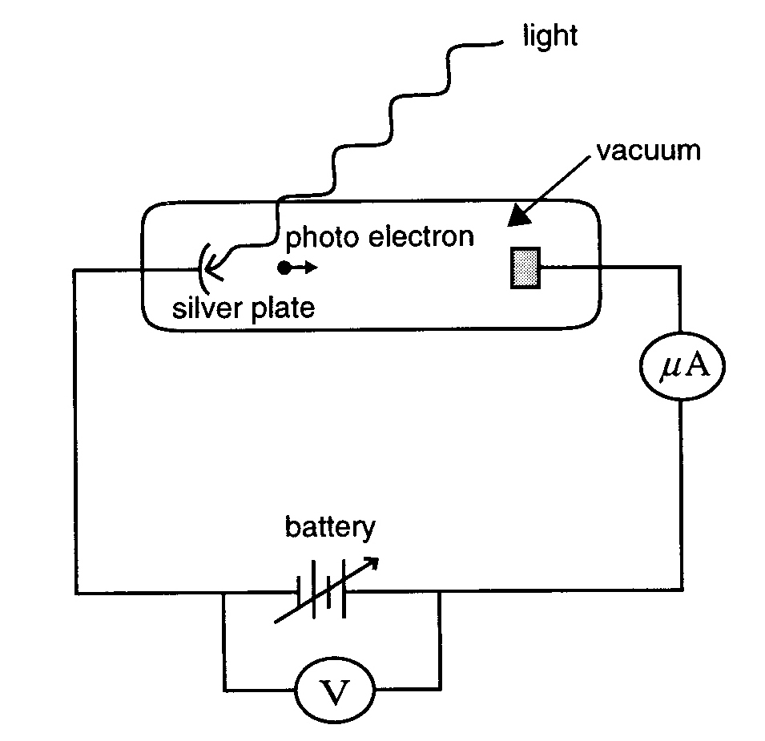

Using this apparatus, it is found that light of wavelength 254 nm (2.54 x 10-7 m) ejects photoelectrons from a silver plate. The work function of the silver surface is 7.52 x 10-19 J.

(b) Calculate the energy of a single photon of light of wavelength 254 nm (2.54 x 10-7 m).

(3 marks)

(c) What is the kinetic energy of the fastest moving photoelectrons ejected by light of 254 nm? (3 marks)

7. An experiment is carried out to investigate the photoelectric effect. Light of various single frequencies shines onto a clean metal plate inside an evacuated glass tube as shown below.

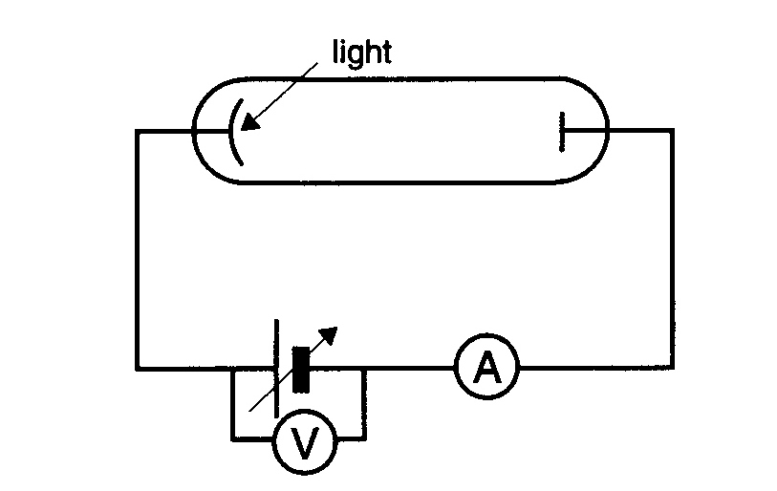

The maximum kinetic energy of the photoelectrons is measured for the different frequencies, giving the results shown below.

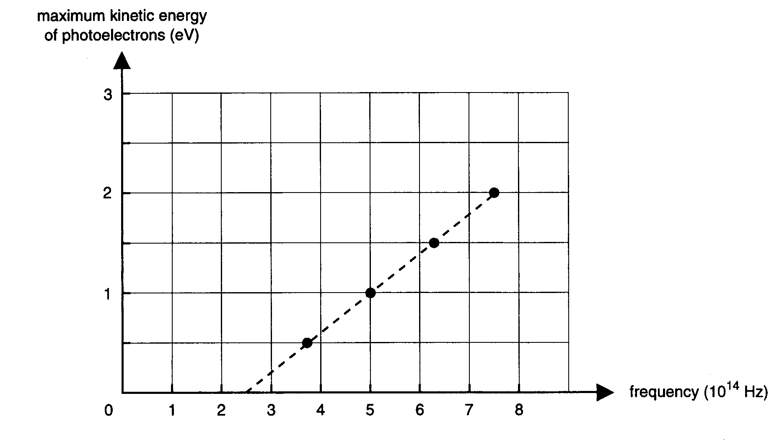

(a) From this graph calculate the value of Planck's constant, *h*, in the units eV. You **must** show your working. (3 marks)

(b) Calculate the minimum retarding voltage needed to prevent an electron of kinetic energy 4.80 x 10-19 J from crossing the evacuated glass tube. (3 marks)

(c) Which one of the plotted lines (A - E) in the graph below would be obtained for the same metal plate for light of double the intensity. (1 mark)

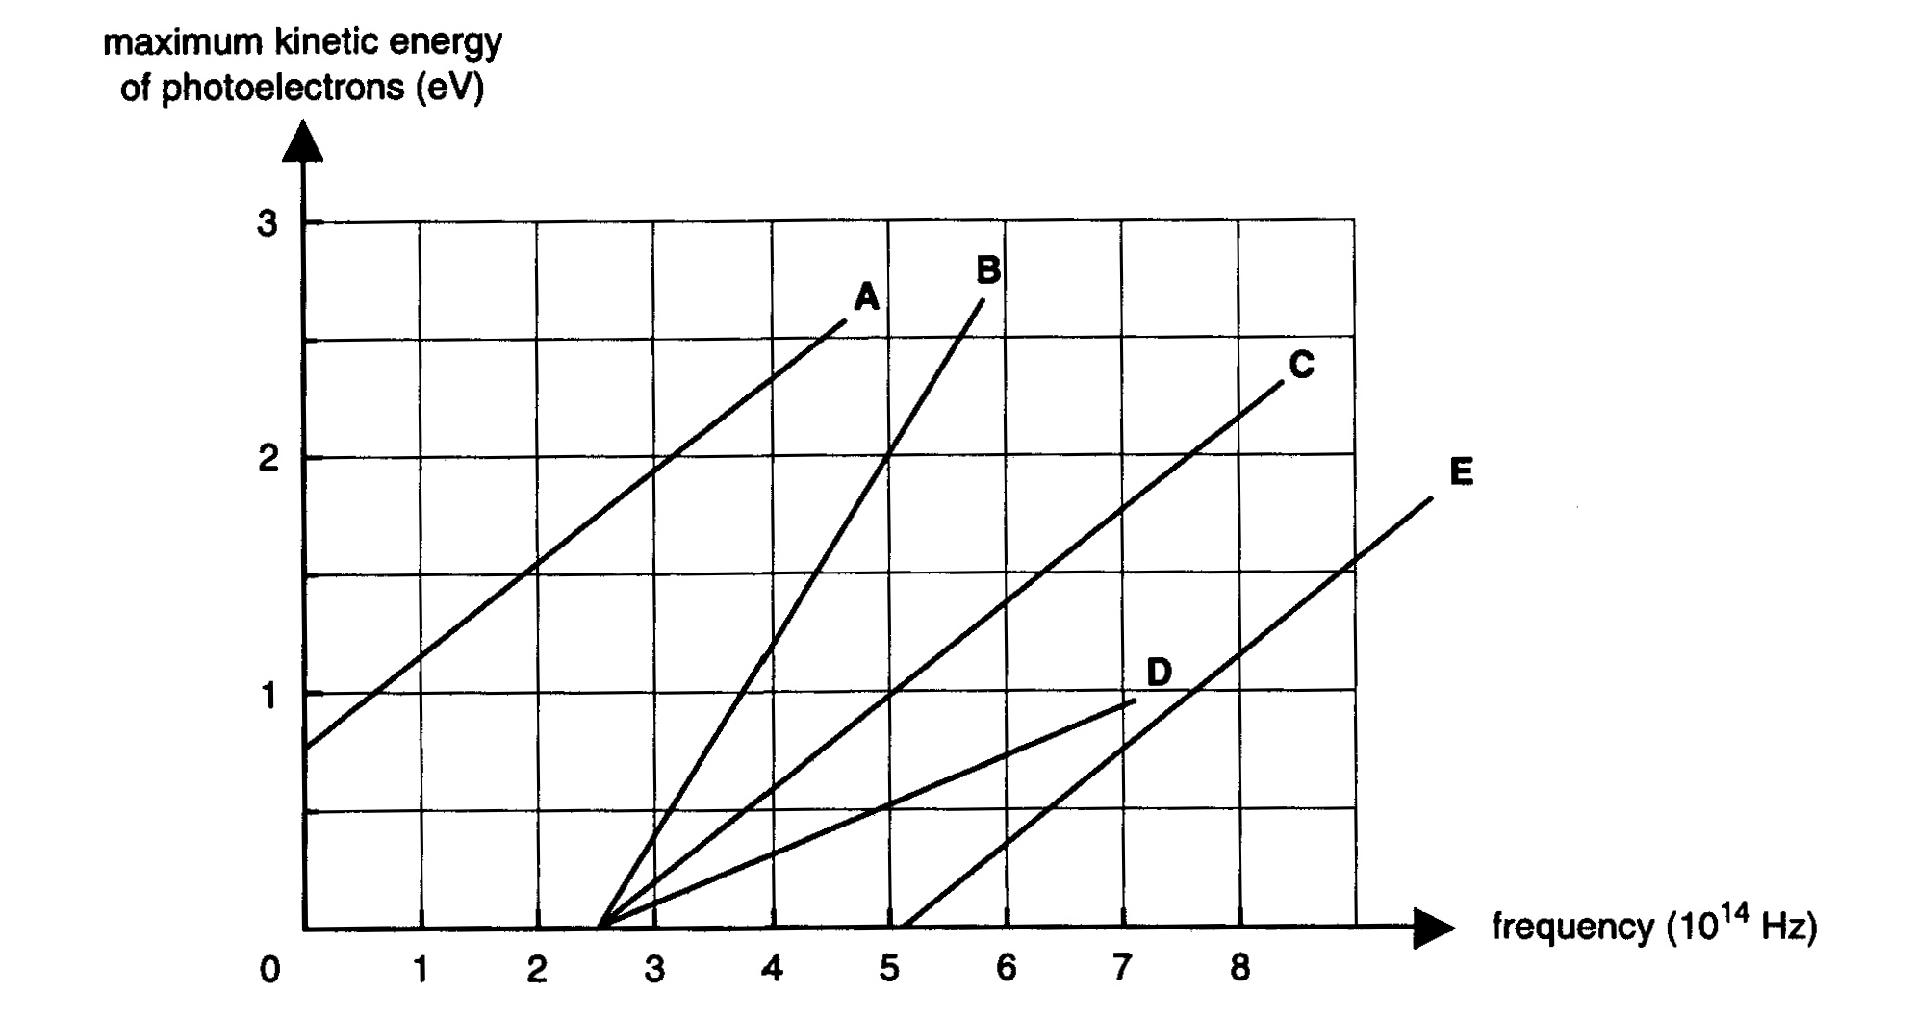

Newton proposed a particle model for light and Huygens proposed a wave model for light.

(d) Explain, giving reasons, how Einstein's interpretation of the photoelectric effect supported a wave or a particle model. (3 marks)

8. A modern X-ray tube is shown in the following figure.

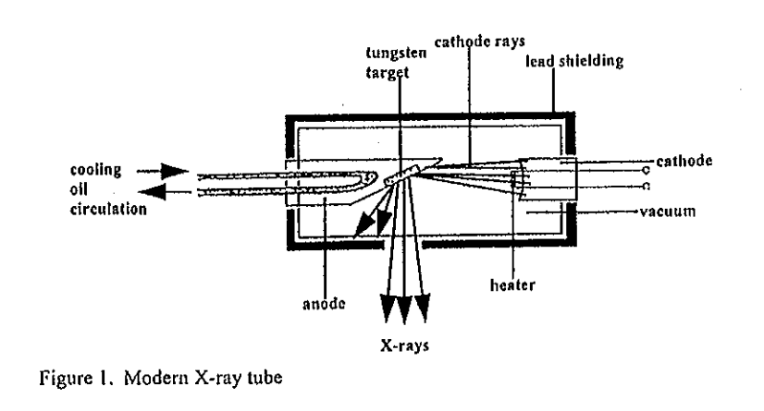

(a) Briefly answer the following questions.

(i) What is the function of the cathode? (1 mark)

(ii)   Is the anode positively or negatively charged in relation to the cathode?

(1 mark)

(iii)   Why does the anode need to be cooled? (2 marks)

(iv)   Explain why lead shielding surrounds the X-ray tube. (2 marks)

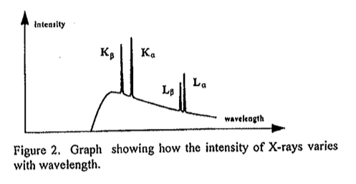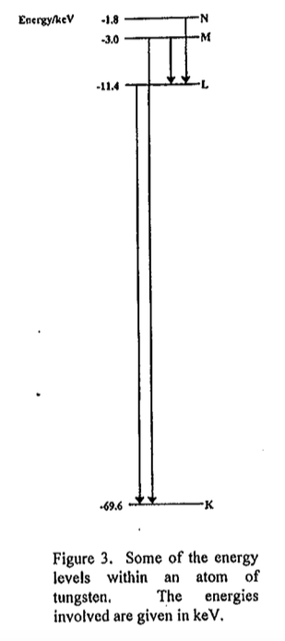

(b) Referring to Figures 2 and 3, answer the following.

(i) What is the frequency of the transition from

-3.00 keV to -69.6 keV? (4 marks)

(ii) This transition is designated the K line.  What is the minimum potential difference that must be applied across the X-ray tube to observe the K line?

(2 marks)

9. An electron microscope creates a coherent beam of electrons which then travels through two narrow slits. The resulting interference pattern is detected on a photographic plate. The speed of the electrons is 1.00% of the speed of light.

(a) Show that the de Broglie wavelength of the electrons used is 2.43 × 10-10 m.

(2 marks)

(b)   Describe what you expect to see on the photographic plate. (2 marks)

(c)   Explain the behaviour of the electrons in this experiment. (2 marks)

(d) If the experiment were to be repeated using protons, at what speed would a proton need to travel to have the same de Broglie wavelength as the electrons? (2 marks)

(e) Calculate the potential difference required for the electron microscope to accelerate the

electrons to 1.00% of the speed of light. (4 marks)

10. An LED can emit three different colours with three different temperatures (K);

i.e. 3000 K (warm white), 4000 K (natural white) and 6000 K (white), with three different radiation energies, *U*3000 K, *U*4000 K and *U*6000 K respectively. (4 marks)

(a) If the intensity is the same for each colour, then the relative electrical energy consumption (*U*) for each colour is:

A *U*3000 K > *U*4000 K > *U*6000 K.

B *U*3000 K = *U*4000 K = *U*6000 K.

C *U*3000 K < *U*4000 K < *U*6000 K.  
 D There is no correlation in terms of energy consumption.

(b)   Which LED emits the greatest proportion of long wavelength radiation?

A   3000 K (warm white)

B   4000 K (natural white)

C   6000 K (white)

D   They are all the same.

(c)   Which LED emits the greatest proportion of high frequency radiation?

A   3000 K (warm white)

B   4000 K (natural white)

C   6000 K (white)

D   They are all the same.

(d)   Which LED emits the greatest proportion of fast photons?

A   3000 K (warm white)

B   4000 K (natural white)

C   6000 K (white)

D   They are all the same.

11. A radio antenna is able to convert electrical signals into radio signals, transmitting information to distant receivers. The antenna does this by oscillating a charge along its length. Describe the waves produced and how the signal is able to be picked up by the receiving antenna. (4 marks)

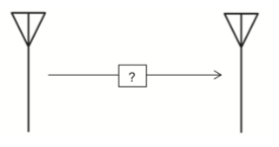

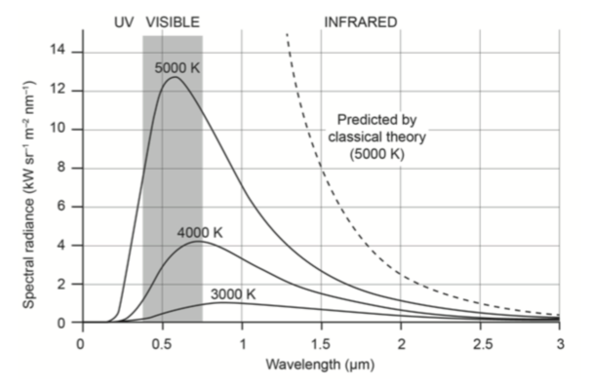

12. Describe the characteristics of a black body and use the black body radiation curves shown right to explain why the concept of light quanta was necessary. (5 marks)

13. Three light sources are used to determine the photoelectric properties of an elemental material surface; ultraviolet (338 nm), violet (386 nm) and yellow (585 nm). These light sources can be used to help determine the work functions given in the following table.

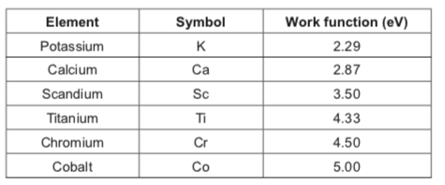

(a) Explain what is meant by the term ‘work function’ as it relates to the photoelectric effect. (2 marks)

(b) (i) Calculate the maximum kinetic energy (in electron volts) of an ejected photoelectron when ultraviolet light is used on a scandium surface. (4 marks)

(ii) Sketch a graph of the kinetic energies of photoelectrons versus the energy of light incident on a scandium surface. (2 marks)

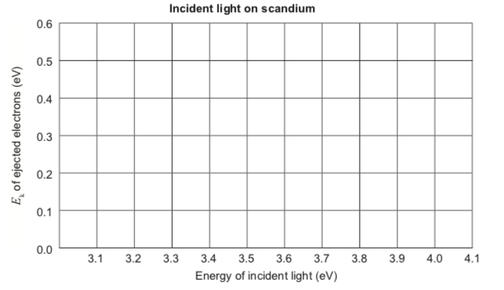

(c) When the violet light is used on an unknown material, a stopping potential difference of 0.350 V reduces the photocurrent to zero.

(i) Calculate the work function of this material. (4 marks)

(ii) From the table on page 26, determine the possible element in the material.  
 (1 mark)

(iii) Explain what happens when the yellow (585 nm) light is incident on the unknown

surface. Include a calculation to support your answer. (4 marks)

(d) Explain how the photoelectric effect demonstrates one of the properties of light.

(3 marks)